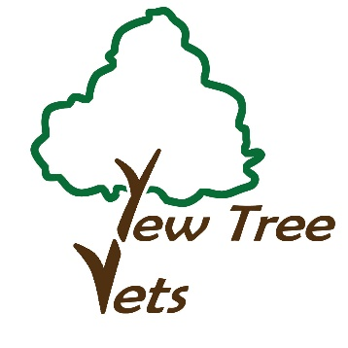
YEW TREE VETERINARY CENTRE
60 Smithbrook Kilns
CRANLEIGH
SURREY
GU6 8JJ
Telephone: (01483) 275665
Email: info@cranleighvets.co.uk
www.cranleighvets.co.uk
Laparoscopy Referral Form
Please hand this form to your Primary Care Vet for completion. Once completed and signed please return it to Yew Tree Veterinary Centre. We will then contact you directly to arrange your pet’s laparoscopic surgery.
Your pet will require a Pre-procedural Consultation at Yew Tree Veterinary Centre, we will contact you to arrange a mutually convenient date.
After the procedure we will email your Primary Care Vet a full clinical history including all after care instructions and follow up required so that you may attend your Primary Care Vets for post-operative follow up.
In addition, you will have medication for the first two days at home and a post-operative care sheet for your pet.
Vet’s details: Practice Name Referring Vet:
Address:
Postcode:
Phone Number: Email Address:
PLEASE PROVIDE FULL CLINICAL HISTORY AND ANY RECENT LAB WORK
Client’s Details: First Name: Surname:
Address:
Postcode:
Phone Numbers:
Email Address:
Animal’s Details: Name:
Age: Sex: Breed: Weight
Reason for referral?.....................................................................
Monthly Lungworm prevention treatment used ……………
Date last applied…………
Date of referral and Vet Signature:……………………………………………..

